Lesson 02 Demo 04

Configuring Alertmanager for Email Notifications

Objective: To set up Prometheus to initiate alerts and validate the alerting and notification system with practical tests for enhanced monitoring and timely responses in system management

Tools required: Linux operating system

Prerequisites: Refer to Demo 01 of Lesson 02 for setting up a Prometheus server and Node Exporter

Steps to be followed:
- Configure Prometheus to work with Alertmanager
- Install and configure Alertmanager
- Start Node Exporter and Prometheus
- Review Alertmanager settings via the Prometheus UI

Step 1: Configure Prometheus to work with Alertmanager

- Run the following commands to navigate to the terminal, change the directory to the Prometheus folder, and open the prom-alertmanager.yml file for editing using the Vim editor:
cd prometheus
sudo vim prom-alertmanager.yml
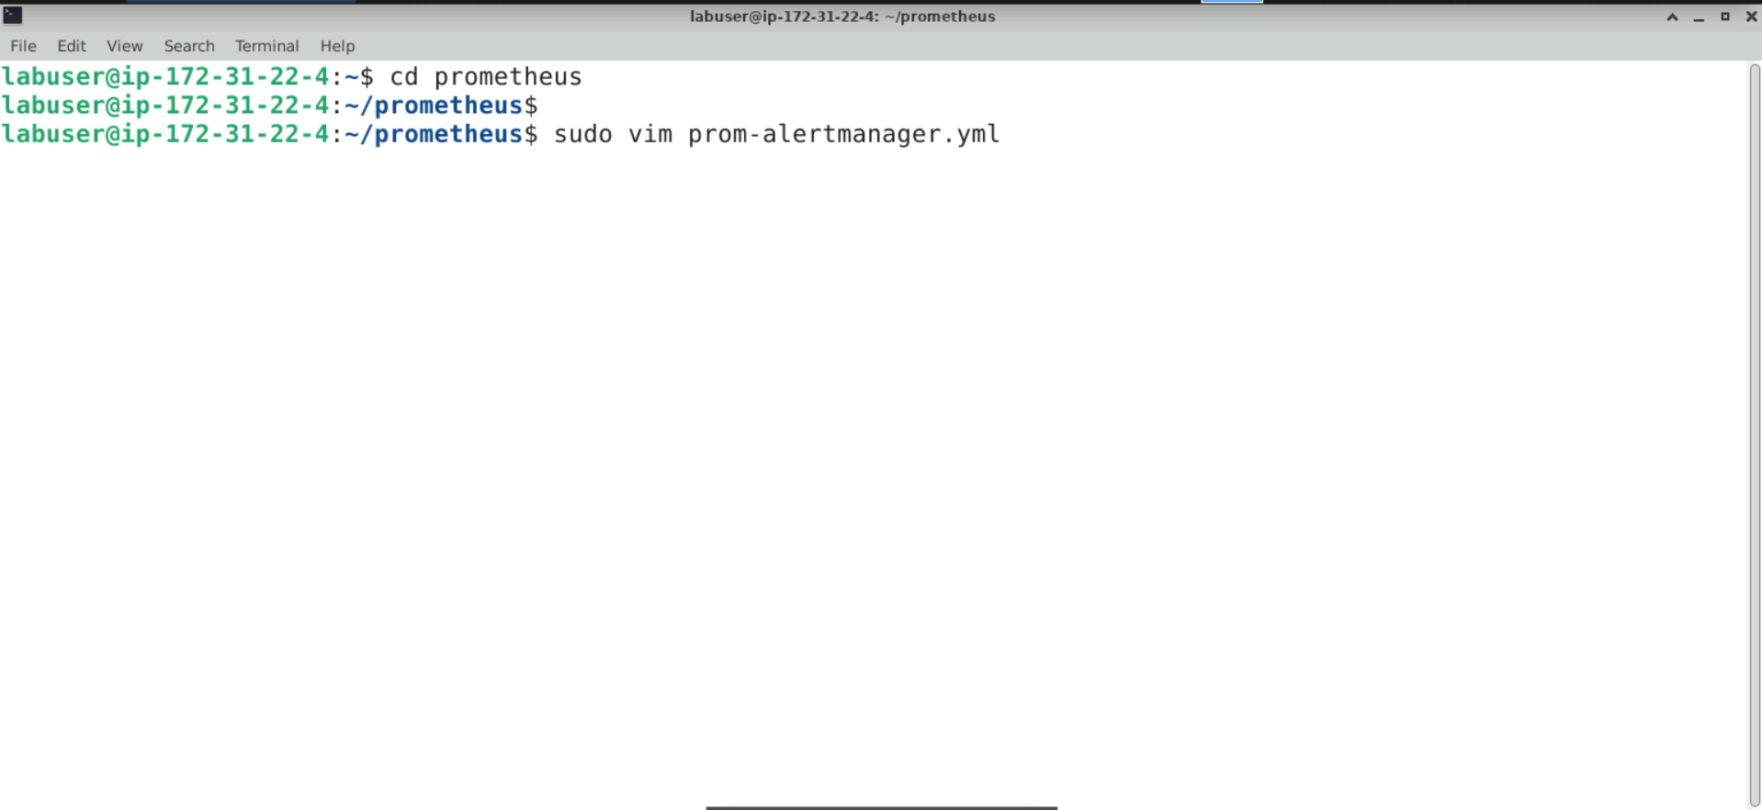

- Switch to INSERT mode by entering I and copy and paste the following configuration:
global:
scrape_interval: 10s

alerting:
alertmanagers:
- static_configs:
- targets:
- localhost:9093

rule_files:
- rules.yml

scrape_configs:
- job_name: prometheus
scrape_interval: 30s
static_configs:
- targets:
- localhost:9090
- job_name: node_exporter
scrape_interval: 30s
static_configs:
- targets:
- localhost:9100

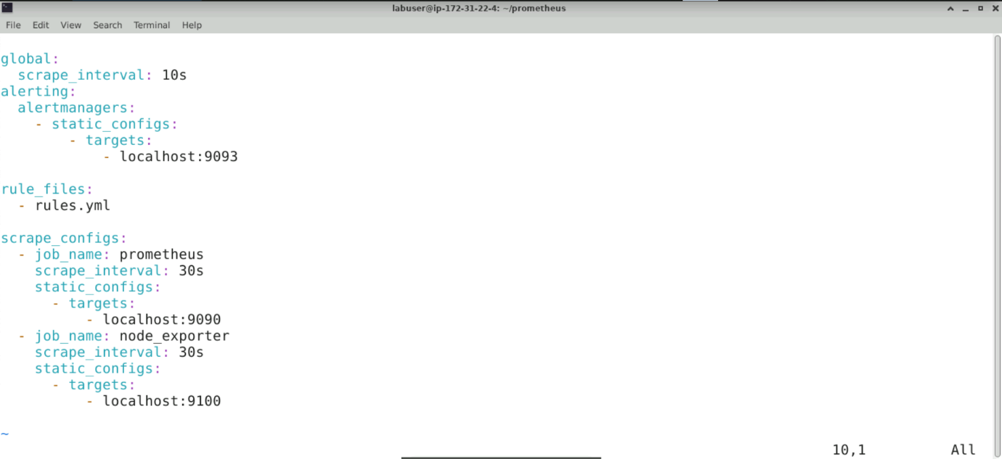
Note: Press esc and type :wq to save and exit the file

- Create a file named rules.yml for the rules configuration using the following:
cat <<EOF | sudo tee rules.yml
groups:
- name: alert.rules
rules:
- alert: InstanceDown
expr: up == 0
for: 1m
labels:
severity: "critical"
annotations:
summary: "Endpoint {{ $labels.instance }} down"
description: "{{ $labels.instance }} of job {{ $labels.job }} has been down for more than 1 minutes."
EOF
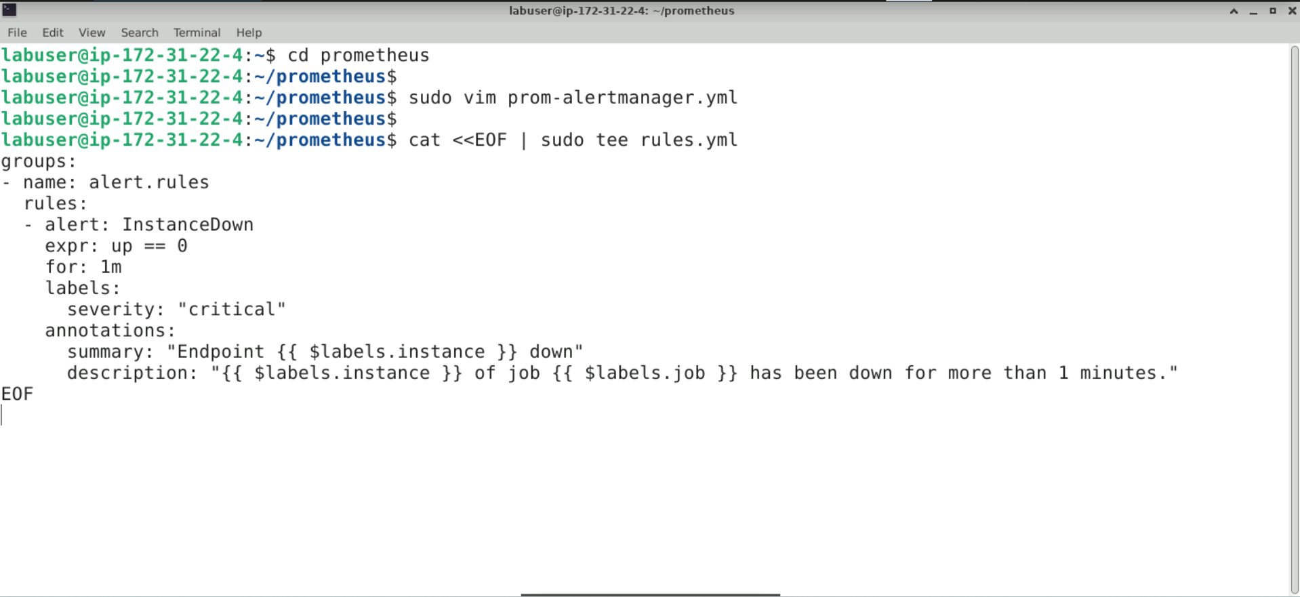
Note: Ensure that the rules.yml file name is the same as the one mentioned in the prom-alertmanager.yml configuration file under rule_files. These Prometheus rules trigger alerts by identifying situations and sending notifications to Alertmanager.

After pressing Enter, the file appears as follows:

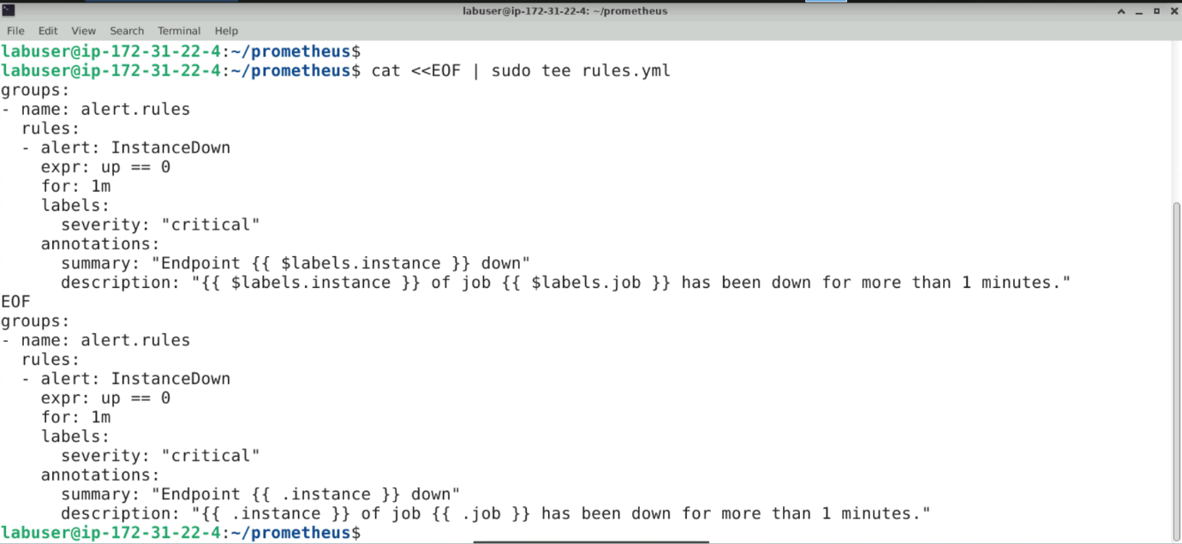

Note: The EOF markers are part of the shell command, not the rules.yml file. They are used to indicate the start and end of the content being written to the file.

Step 2: Install and configure Alertmanager
  - Change the directory and download and install Alertmanager using the following command:
sudo wget https://github.com/prometheus/alertmanager/releases/download/v0.27.0/alertmanager-0.27.0.linux-arm64.tar.gz

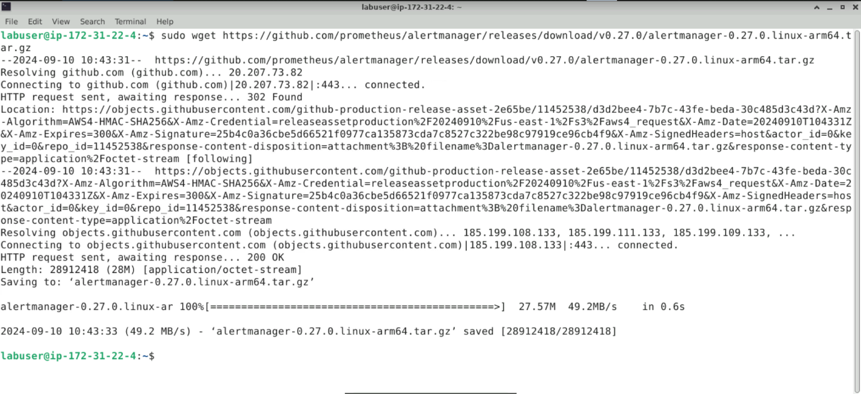

  - Execute the following command to extract the downloaded Alertmanager file:
sudo tar xvfz alertmanager-0.27.0.linux-arm64.tar.gz

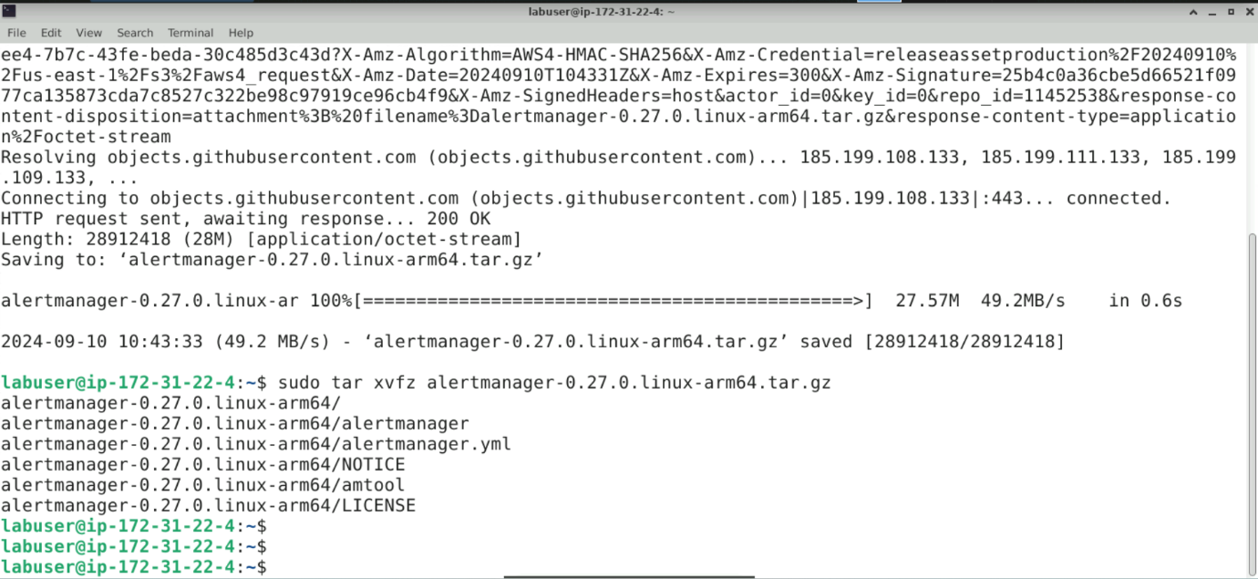

  - Change the directory to the Alertmanager folder and create a custom configuration file named alertmanager-email.yml using the following commands:
cd alertmanager-0.27.0.linux-arm64/
sudo vim alertmanager-email.yml

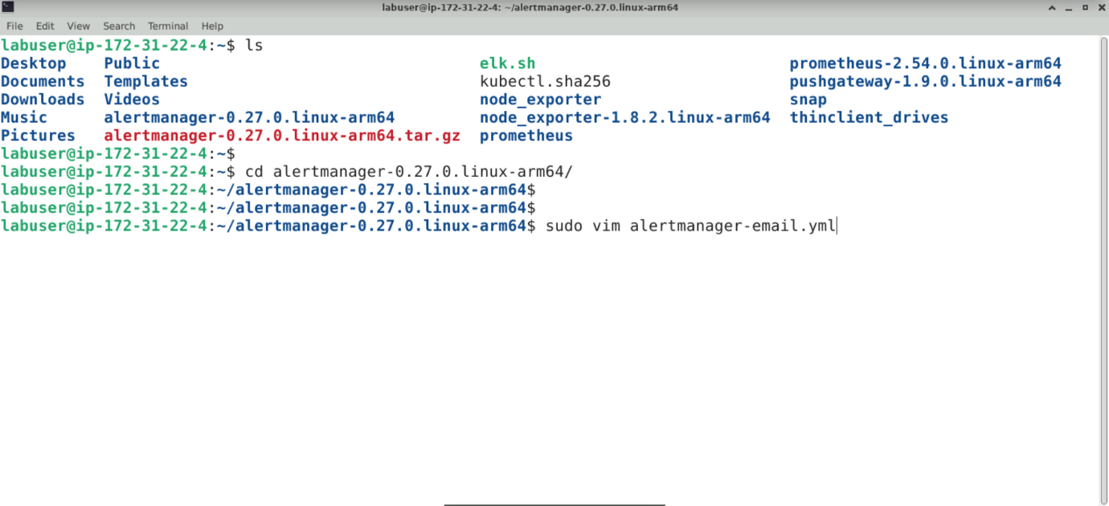

  - Copy and paste the following configuration and save and exit the file:
global:
resolve_timeout: 1m
smtp_smarthost: smtp.gmail.com:587
smtp_from: your-email1@gmail.com
smtp_auth_username: your-email1@gmail.com
smtp_auth_password: <your_gmail_password>
smtp_require_tls: true

templates:
- /etc/alertmanager/template/*.tmpl

route:
group_by:
- alertname
group_wait: 30s
group_interval: 10s
repeat_interval: 1h
receiver: email-notifications

receivers:
- name: email-notifications
email_configs:
- to: your-email2@gmail.com
send_resolved: true
require_tls: true

inhibit_rules:
- source_match:
severity: critical
target_match:
severity: warning
equal:
- alertname
- instance

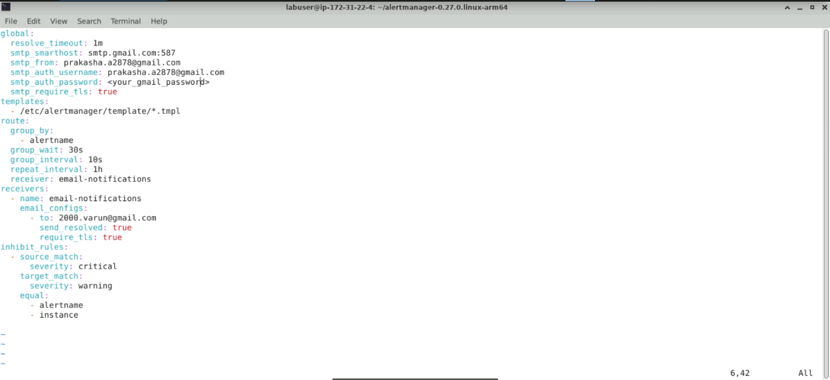
Note: In this demo, Gmail is used for sending email notifications. The smtp_from field represents the sender's and receiver's email ID. Configure the sender’s email ID, password, and SMTP settings. In a real-world scenario, your work email will be configured for the same, replace your-email@gmail.com with your actual email

  - Start Alertmanager in the background using the following command:
sudo ./alertmanager --config.file alertmanager-email.yml > /dev/null 2>&1 &

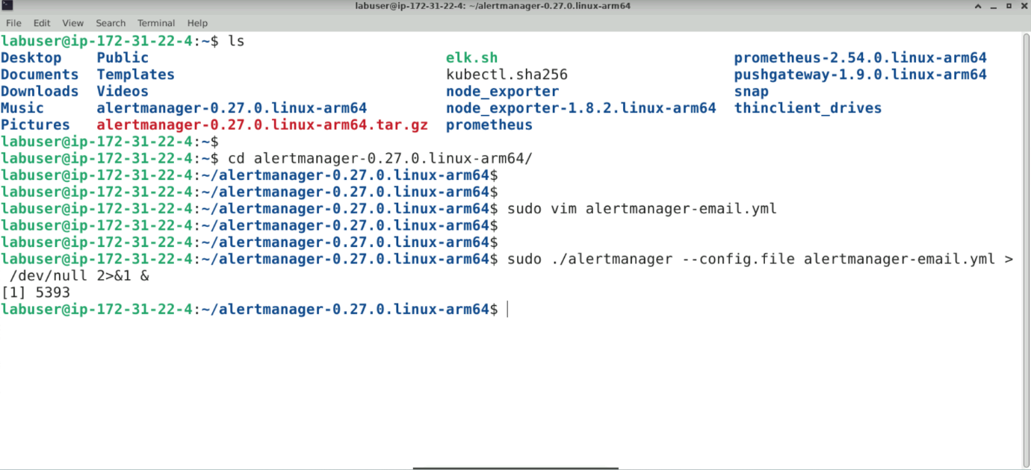

Step 3: Start Node Exporter and Prometheus

  - Execute the following commands to change the directory to node_exporters and
start it in the background:
ls
cd node_exporter
sudo ./node_exporter > /dev/null 2>&1 &

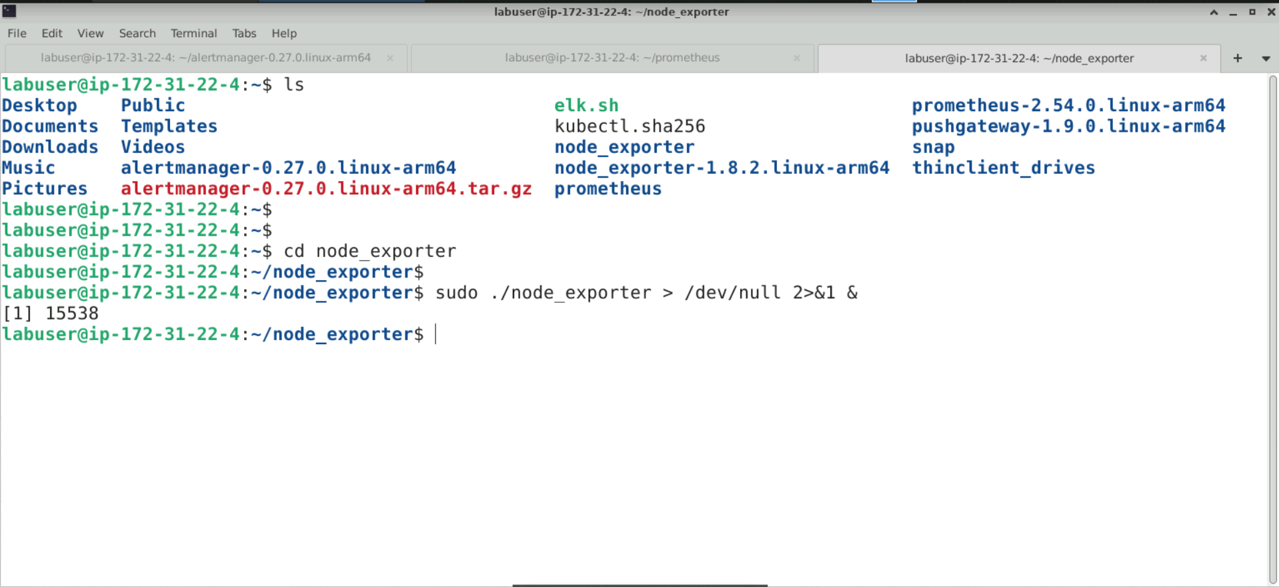

  - Change the directory and run the following commands to start Prometheus UI:
ls
cd prometheus
sudo ./prometheus --config.file=prom-alertmanager.yml

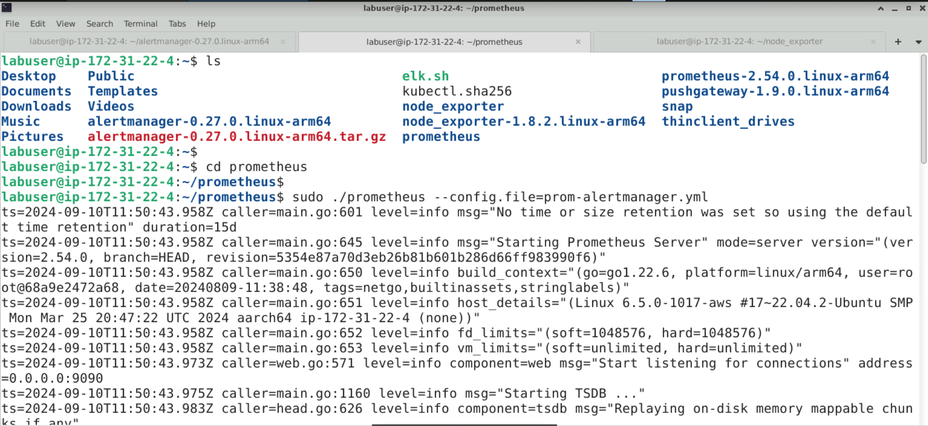

Step 4: Review Alertmanager settings via the Prometheus UI

  - Review Alertmanager settings through the Prometheus UI by entering the URL http://localhost:9090/alerts in the browser as shown:

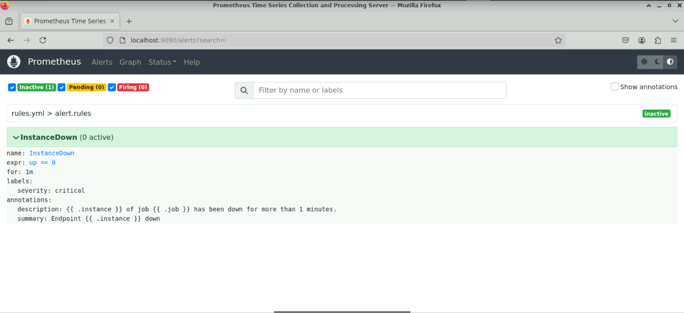

  - Navigate to the terminal and stop the Node Exporter process using the following command:
ps -aux | grep node_exporter
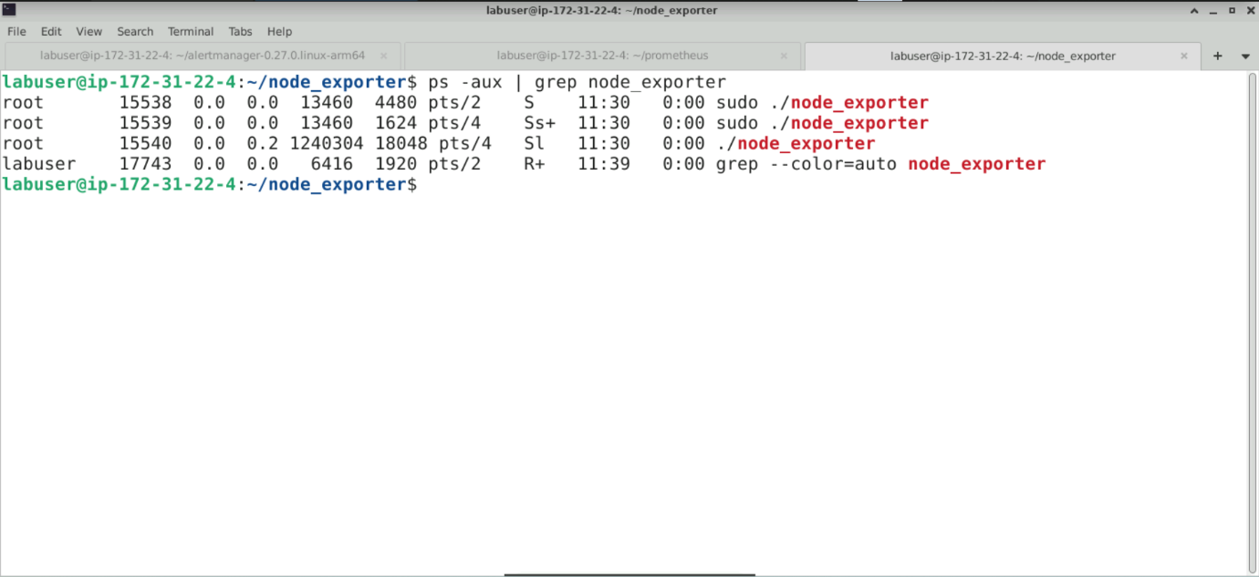

  - Run the following command to kill the Node Exporter:
sudo kill <PID of node_exporter>

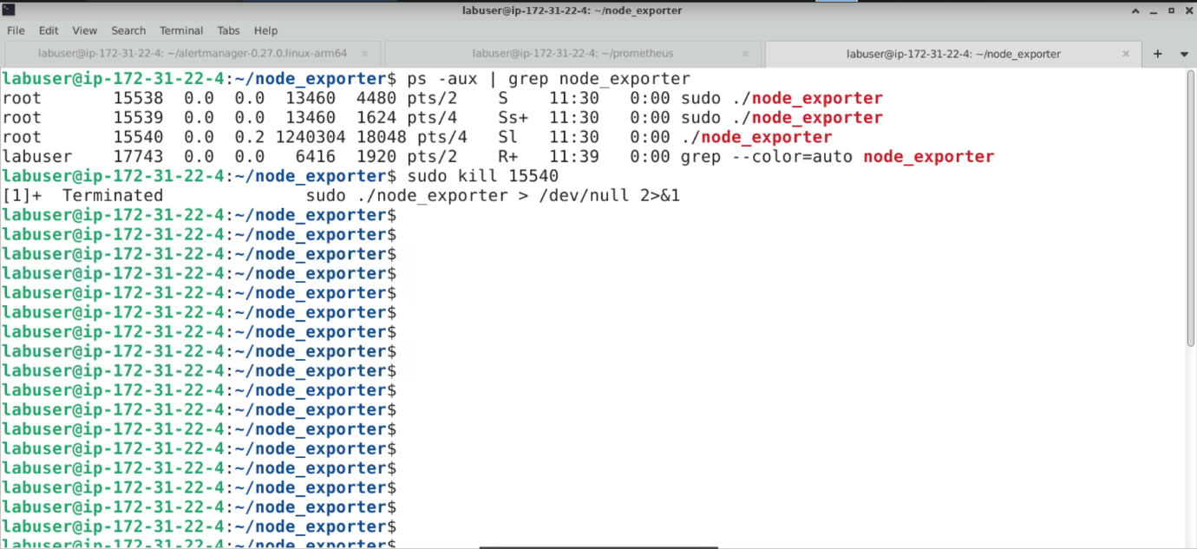

  - Go to the browser, refresh the Prometheus UI, and observe that the InstanceDown status has changed from 0 active to 1 active, causing the alert to fire

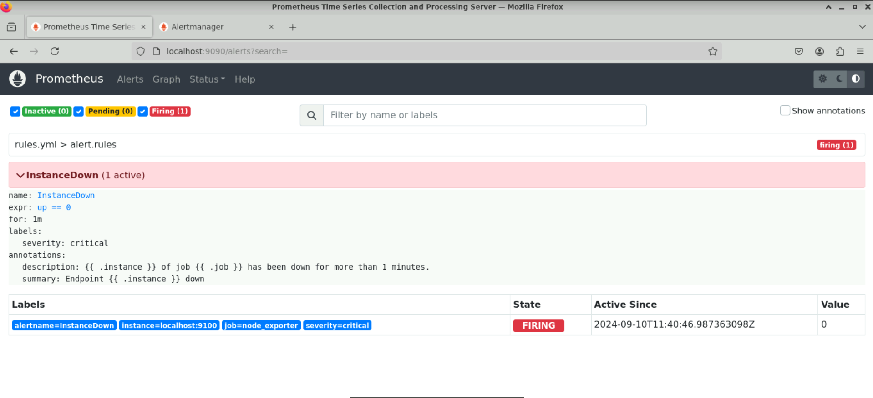
Note: To verify the rules and configurations, the Node Exporter process will be stopped manually to emulate an Instance Down issue.

  - Open a new tab in the browser and enter the URL http://localhost:9093 to see the same status on the Alertmanager UI as follows:

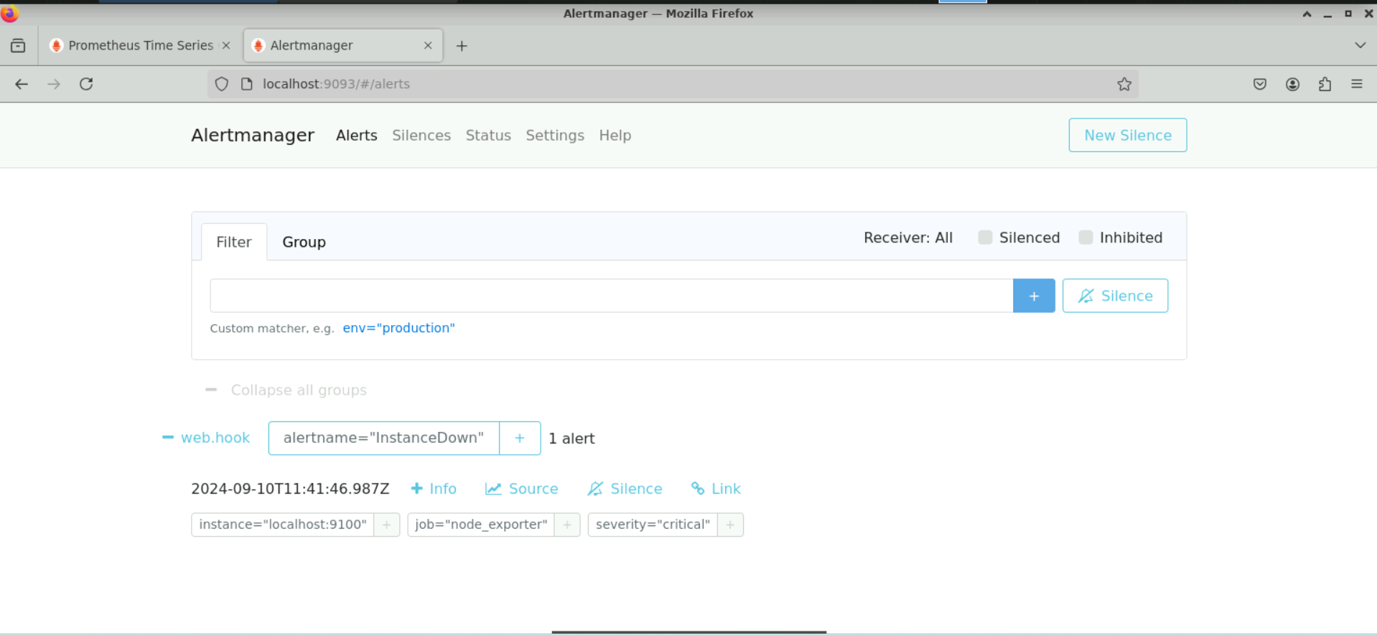

By following these steps, you have successfully set up Alertmanager for email notifications, configured Prometheus to send alerts to Alertmanager, and validated the alerting setup by testing alert triggers and checking the notification system.

